Straight to the Point Archery

Site Information Architecture Proposal

Background

The ‘About the Users’ section in the doc provided by the client says “…people who use the site are mostly current and prospective students. They're interested in learning about the facilities and services available, as well as being reminded of the class schedule and location.” With that in mind I looked at the text in the word doc she gave us and the images and split it up across 7 pages, Home, Classes, Private Lessons, Events, Schedule, Our Instructors, and About Us. We could do it with fewer pages but this seemed like a good way to highlight the stuff people are interested in. It also keeps the pages pretty text-light, which I like.

Here are some wireframes. I didn’t think much about page design, I was just trying to figure out an info architecture, and I’m not married to this version so feel free to propose changes.

Home page – Highlights education, classes, and the facility. The page nav also makes it obvious that they have classes, lessons, events. (I stuck the nav on the left but it could be at the top. I also put the contact info in the nav panel so it’s visible on every page but that could move into a footer.)

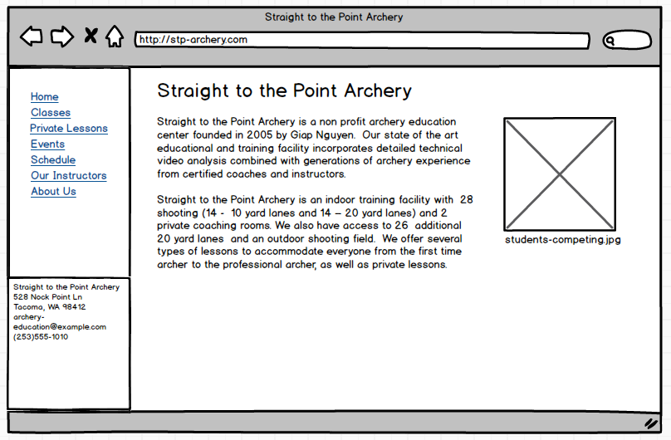

Classes page – A little overview text and a list of the classes.

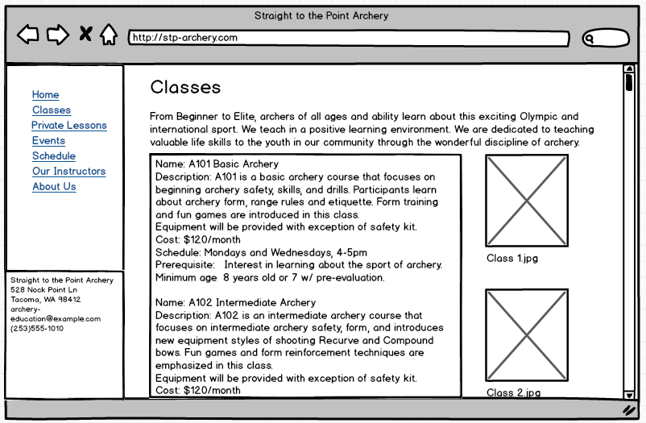

Private lessons page – We could combine this with the classes page. I split it out in this version just to call more attention to the fact that they have both group classes and private lessons.

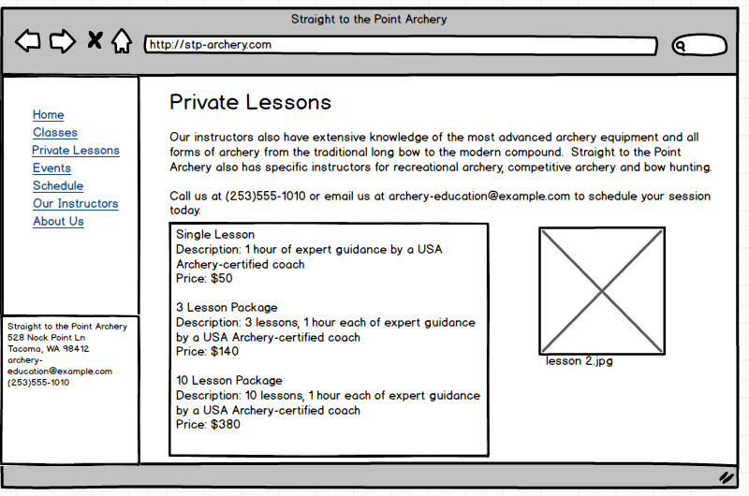

Events page – not a lot of info for this page but it seemed like a cool thing they offer that’s worth highlighting.

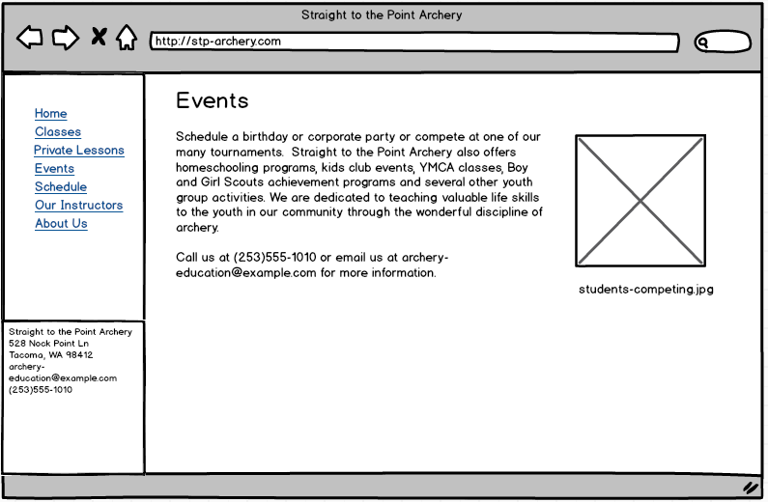

Schedule page – I’m not sure if this is valuable or not. The doc says one of the primary purposes of the site is for students to get reminded of when the classes are. They could get that by looking at the Classes page but this might make it easier.

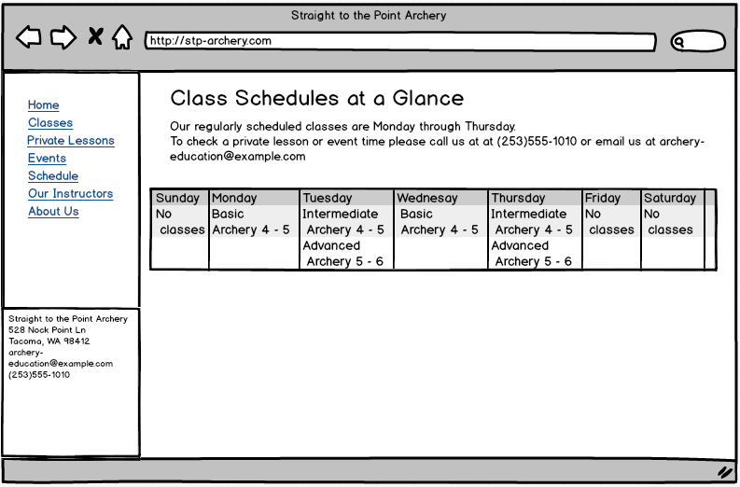

Our Instructors page – Pretty basic

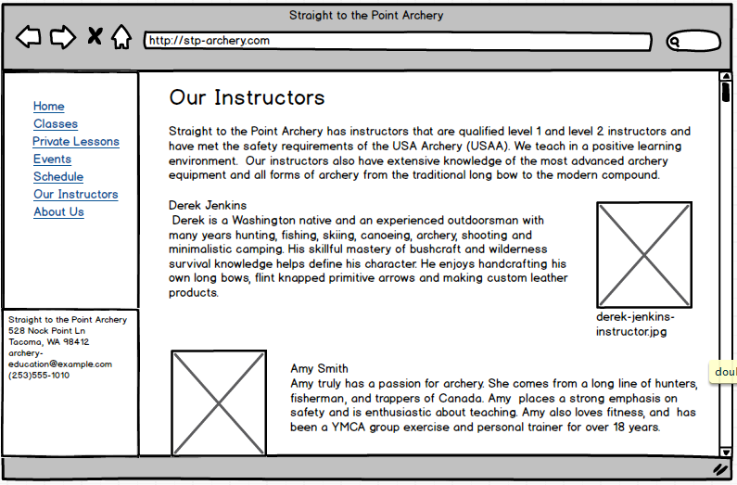

About Us page – Not sure if we need this or not. I put it in because there’s a lot of info in the doc that was about the organization that didn’t really seem to belong anywhere else. What do you think?

